**Record And Playback Selenium IDE Test Case**

## Steps to Record Selenium IDE Test Script

1. Launch Firefox and Launch Selenium IDE by Clicking on ***Tools => Selenium IDE***. A pop up window would be displayed. Type the Base URL value: [**http://store.demoqa.com**](http://store.demoqa.com/)**.** Click on the ***Record***button to start the recording of the Test Case.

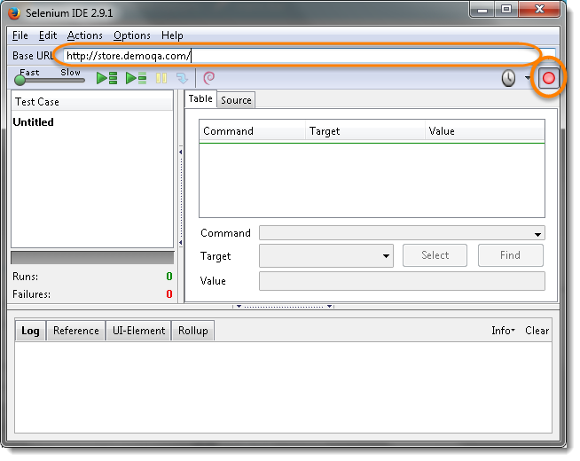  
2. In Firefox, navigate to http://store.demoqa.com. Firefox should take you to the page similar to the one shown below.  
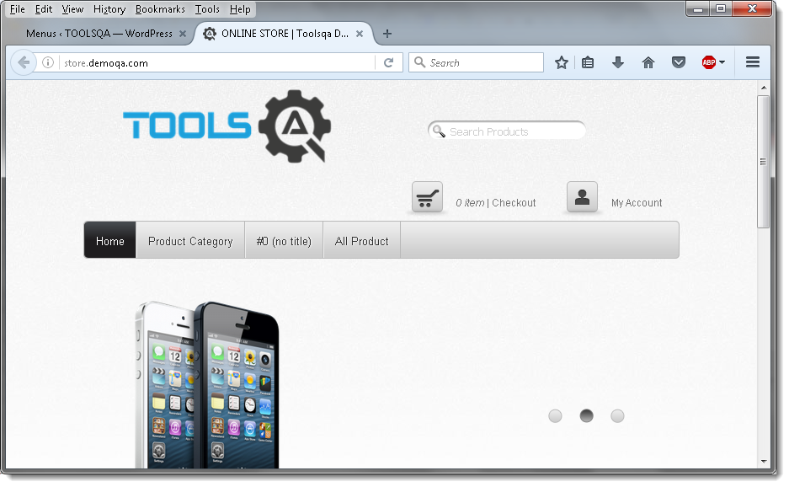

3. Right-click on any blank space within the page, this will bring up the Selenium IDE context menu. Select the ***Show Available Commands*** option. Then, select **assertTitle ONLINE STORE | Toolsqa Dummy Test site**. This is a command that makes sure that the page title is correct.  
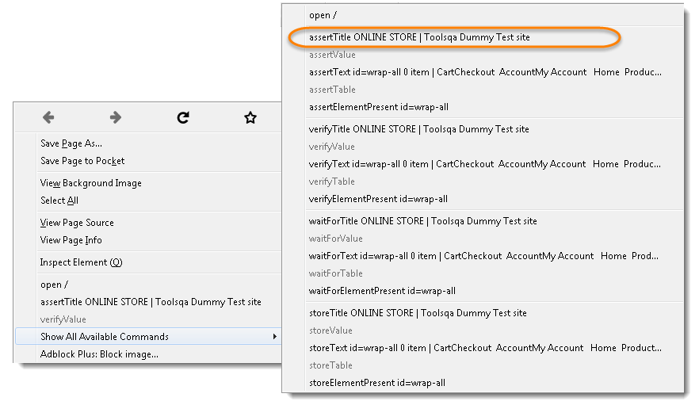

4. Click on ***My Account*** link to enter credentials.

5. Enter UserName ***TestUser*** in the first text box and Password ***Test@@123*** in the second text box. Then click on ***LogIn*** button to submit.  
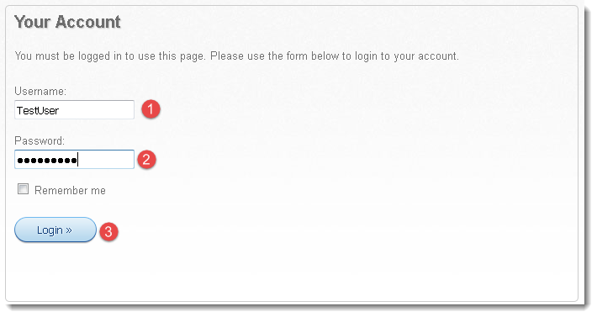

***Note***: These credentials are not correct. Once submit, the application will show the error message. Please create your own User.

6. Stop the recording by clicking on the ***Record*** button. In the ***Table*** tab of [***Test Step Pane***](http://toolsqa.com/selenium-ide/test-step-pane/) you can see the commands recorded by selenium IDE.  
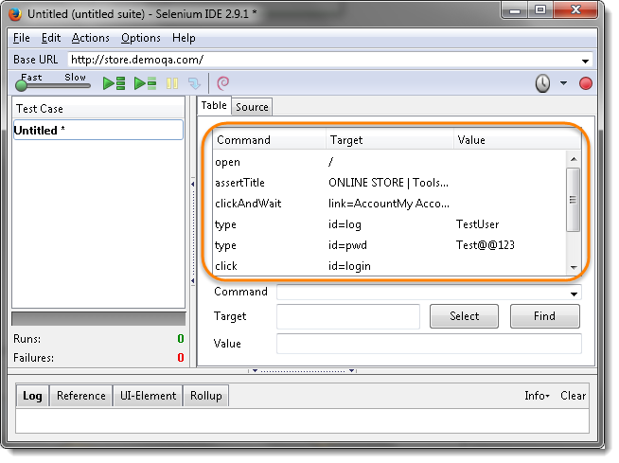

7. In the ***Source***tab it shows the ***HTML Code***generated by selenium IDE.  
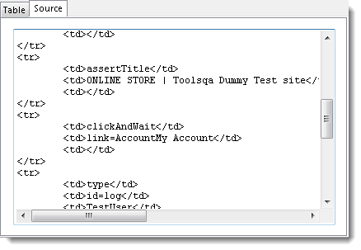

## Steps to Save Selenium IDE Test Script

1. Save the test case for future use by clicking on ***File -> Save Test Case As***.  
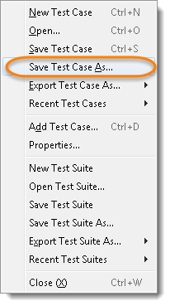

2. Choose your location, and then name the test  as ***Invalid Login***. Click the ***Save*** button.  
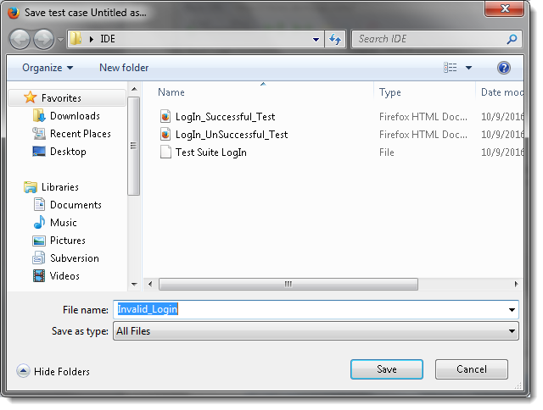

3. Saved test case name will appear on the left hand side.  
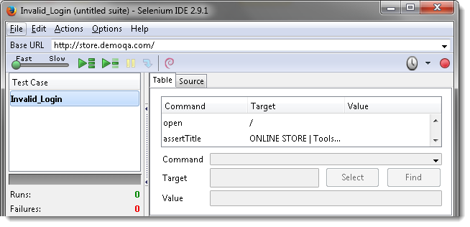

4. The file was saved as HTML.  
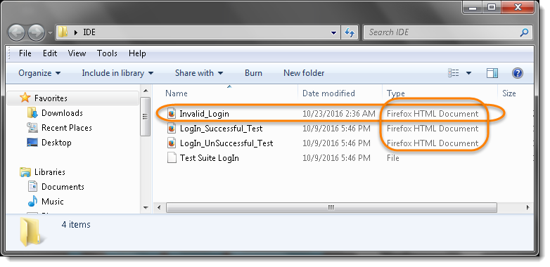

## Steps to PlayBack Selenium IDE Test Script

1. To Play the current recorded test, open a new tab window in Firefox and click on the ***Play*** button in Selenium IDE  
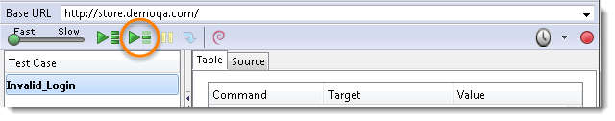

Noticed Selenium IDE will run the complete test which was earlier recorded.Once the test is finished, it will display the result in the [***Test Case Pane***](http://toolsqa.com/selenium-ide/test-case-pane/).